CREATE DATABASE Employee;

USE Employee;

CREATE TABLE EmployeeDetails
(
EmpId BIGINT PRIMARY KEY UNIQUE,
FullName VARCHAR(255) not null,
ManagerId BIGINT not null,
DateOfJoining date not null
);

INSERT INTO EmployeeDetails VALUES
(121,'John Snow',321,'2015/01/31'),
(321,'Rahul Dravid',986,'2016/01/30'),
(421,'Tom Cruise',786,'2017/11/27'),
(521,'Narendra Modi',976,'2017/04/02');

CREATE TABLE EmployeeSalary
(
EmpId BIGINT NOT NULL,
Project VARCHAR(20),
Salary INT NOT NULL,
FOREIGN KEY EmpId_ForeignKey(EmpId) REFERENCES EmployeeDetails(EmpId)
);

INSERT INTO EmployeeSalary VALUES
(121,'Microsoft Office',8000),
(321,'Facebook',10000),
(421,'WhatsApp',12000);

SELECT * FROM EmployeeDetails;

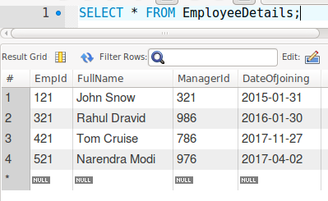

SELECT * FROM EmployeeSalary;

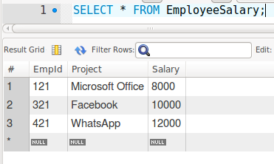

- to fetch total number of employees working on project ‘Microsoft Office’

SELECT COUNT(EmployeeDetails.EmpId)
FROM EmployeeDetails
INNER JOIN EmployeeSalary
ON EmployeeDetails.EmpId = EmployeeSalary.EmpId
WHERE EmployeeSalary.Project = "Microsoft Office";

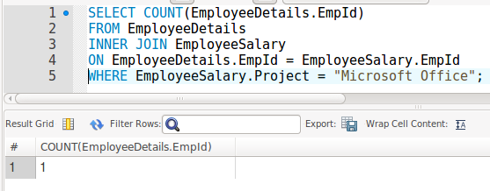

- to fetch name of the employee with maximum salary

SELECT *
FROM EmployeeDetails
INNER JOIN EmployeeSalary
ON EmployeeDetails.EmpId = EmployeeSalary.EmpId
ORDER BY EmployeeSalary.Salary DESC LIMIT 1;

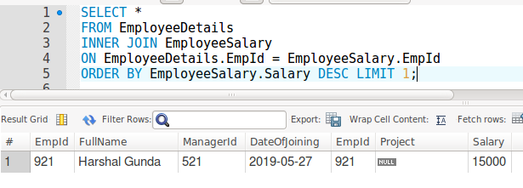
- to fetch employees who joined between 1 Jan 2016 and 1 Oct 2017

SELECT FullName
FROM EmployeeDetails
WHERE DateOfJoining
BETWEEN '2016-01-01' AND '2017-10-01';

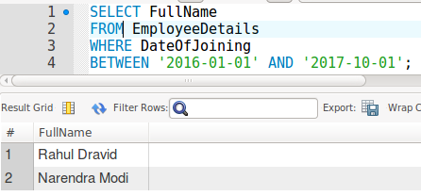

- to fetch first two records of EmployeeDetails

SELECT *
FROM EmployeeDetails
LIMIT 2;

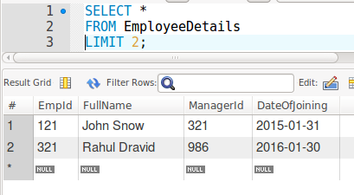

- to fetch employees with salary above 10000

SELECT *
FROM EmployeeDetails
INNER JOIN EmployeeSalary
ON EmployeeDetails.EmpId = EmployeeSalary.EmpId
WHERE EmployeeSalary.Salary>10000;

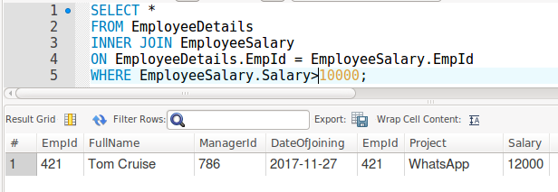

- to fetch ManagerId and how many sub-ordinates they have

SELECT EmployeeDetails.ManagerId,
COUNT(EmployeeDetails.EmpId) AS Sub_Ordinates
FROM EmployeeDetails
GROUP BY EmployeeDetails.ManagerId;

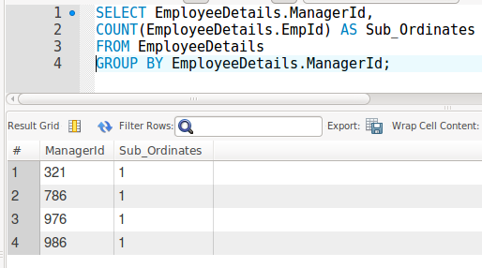

- to fetch employee names and their manager names

SELECT EmployeeDetails1.FullName AS Employee,
EmployeeDetails2.FullName AS Manager
FROM EmployeeDetails AS EmployeeDetails1
JOIN EmployeeDetails AS EmployeeDetails2
ON EmployeeDetails2.EmpId = EmployeeDetails1.ManagerId;

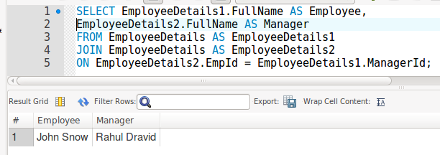
- to fetch employees with no project assigned

SELECT *
FROM EmployeeDetails
INNER JOIN EmployeeSalary
ON EmployeeDetails.EmpId = EmployeeSalary.EmpId
WHERE EmployeeSalary.Project = NULL;

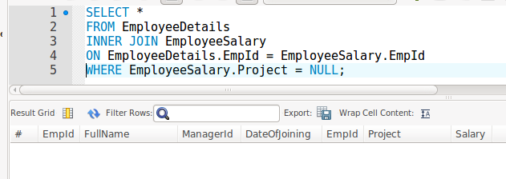

- to update joining date of ‘Rahul Dravid’ to ’03/10/2014’

UPDATE EmployeeDetails
SET DateOfJoining = '2014-03-10'
WHERE FullName = 'Rahul Dravid';

SELECT * FROM EmployeeDetails;
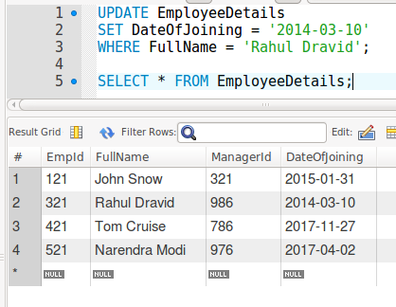

- to insert your favourite employee details and their salary details in above tables

INSERT INTO EmployeeDetails VALUES
(921,'Harshal Gunda',521,'2019-05-27');

SELECT * FROM EmployeeDetails;
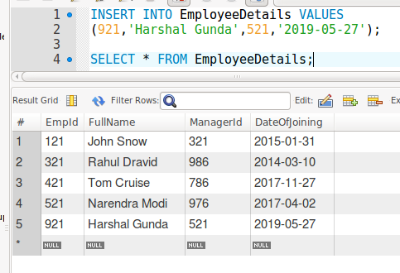

INSERT INTO EmployeeSalary(EmpId,Salary) VALUES
(921,15000);

SELECT * FROM EmployeeSalary;
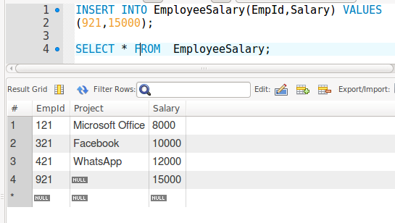

- to fetch all employees even if they don’t have any project assignment; sort the results based on ‘DateOfJoining’, display recently joined employees first
SELECT *
FROM EmployeeDetails
ORDER BY DateOfJoining DESC;

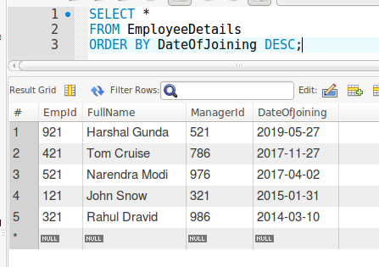

- to display following columns: FullName, ManagerName, Project, Salary

SELECT Emp.FullName AS Employee,
Manager.FullName AS Manager,
EmpSalary.Project,EmpSalary.Salary
FROM EmployeeDetails AS Emp
JOIN EmployeeDetails AS Manager
ON Emp.ManagerId=Manager.EmpId
INNER JOIN EmployeeSalary AS EmpSalary
ON Emp.EmpId = EmpSalary.EmpID;

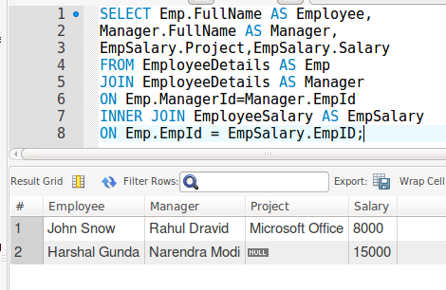

- to fetch employees who are not part of project ‘Facebook'

SELECT EmployeeDetails.FullName
FROM EmployeeDetails
INNER JOIN EmployeeSalary
ON EmployeeDetails.EmpId = EmployeeSalary.EmpId
WHERE EmployeeSalary.Project!="Facebook";

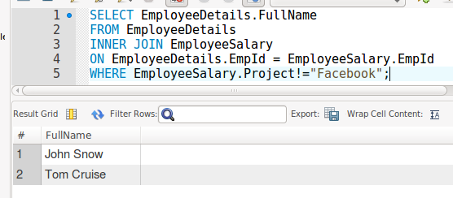

- display your name and date of birth

SELECT "Harshal Gunda" as Name,
"3rd November 1995" Birth_Date;

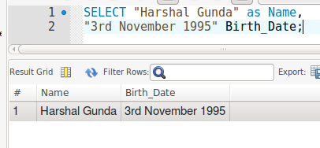

- display today’s date and your age in years

SELECT CURDATE() AS Todays_Date,
(EXTRACT(YEAR FROM CURDATE())) - 1995 AS Age FROM DUAL;

